* Copyright for test papers and marking guides remains with *West Australian Test Papers*.
* The papers may only be reproduced within the purchasing school according to the advertised conditions of sale.
* Test papers must be withdrawn after use and stored securely in the school until Friday June 15

**HUMAN BIOLOGY**

**Unit 3**

**2018**



Name: _______________________________________________________

Teacher: ___________________________________________________

***TIME ALLOWED FOR THIS PAPER***

Reading time before commencing work: Ten minutes

Working time for the paper: Three Hours

***MATERIALS REQUIRED/RECOMMENDED FOR THIS PAPER***

**To be provided by the supervisor:**

* This Question/Answer Booklet
* Multiple Choice Answer Sheet

**To be provided by the candidate:**

* Standard items: Pens, pencils, eraser or correction fluid, ruler, highlighter, ruler.
* Special items: Calculators satisfying the conditions set by the Schools

Curriculum and standards authority for this subject.

***IMPORTANT NOTE TO CANDIDATES***

* No other items may be taken into the examination room. It is **your** responsibility to ensure that you do not have any unauthorised notes or other items of a non-personal nature in the examination room. If you have any unauthorised material with you, hand it to the supervisor **before** reading any further.

***Structure of this paper***

|  |  |  |  |  |  |
| --- | --- | --- | --- | --- | --- |
| Section | Suggested working time | Number of questions available | Number of questions to be attempted | Marks | Percentage |
| SECTION ONE:  Multiple-choice | 50 minutes | 30 | All | 30 | 30 |
| SECTION TWO:  Short answers | 90 minutes | 8 | All | 100 | 50 |
| SECTION THREE:  Extended answers | 40 minutes | 3 | 2 | 40 | 20 |
|  |  |  | Total marks | 170 | 100 |

**Instructions to candidates**

1. The rules for the conduct of Western Australian external examinations are detailed in the *Year 12 Information Handbook 2018.* Sitting this examination implies that you agree to abide by these rules.

2. Answer the questions according to the following instructions.

Section One: Answer all questions on the separate Multiple-choice Answer Sheet provided. For each question shade the box to indicate your answer. Use only a blue or black pen to shade the boxes. If you make a mistake, place a cross through that square, do not erase or use correction fluid, and shade your new answer. Marks will not be deducted for incorrect answers. No marks will be given if more than one answer is completed for any question.

Sections Two and Three: Write your answers in this Question/Answer Booklet.

3. You must be careful to confine your responses to the specific questions asked and to follow any instructions that are specific to a particular question.

4. Spare pages are included at the end of this booklet. They can be used for planning your responses and/or as additional space if required to continue an answer.

* Planning: If you use the spare pages for planning, indicate this clearly at the top of the page.
* Continuing an answer: If you need to use the space to continue an answer, indicate in the original answer space where the answer is continued, i.e. give the page number. Fill in the number of the question(s) that you are continuing to answer at the top of the page.

**Multiple choice answers**

|  |  |  |  |
| --- | --- | --- | --- |
| 1 | C | 16 | D |
| 2 | D | 17 | B |
| 3 | A | 18 | A |
| 4 | B | 19 | D |
| 5 | D | 20 | B |
| 6 | D | 21 | D |
| 7 | A | 22 | C |
| 8 | D | 23 | A |
| 9 | C | 24 | C |
| 10 | B | 25 | B |
| 11 | C | 26 | D |
| 12 | B | 27 | B |
| 13 | D | 28 | A |
| 14 | B | 29 | A |
| 15 | C | 30 | C |

**Section One: Multiple-choice 30% (30 Marks)**

This section has **30** questions. Answer **all** questions on the separate Multiple-choice Answer Sheet provided. For each question shade the box to indicate your answer. Use only a **blue or black pen** to shade the boxes. If you make a mistake, place a cross through that square, do not erase or use correction fluid, and shade your new answer. Marks will not be deducted for incorrect answers. No marks will be given if more than one answer is completed for any question.

Suggested working time: 40 minutes.

1. The endocrine gland that is correctly matched to the hormone it releases and its function

is:

* 1. Anterior pituitary lobe, oxytocin, contraction of uterus.
  2. Thymus, thymosins, maturation of B-lymphocytes.
  3. Pineal, melatonin, regulates sleep patterns.
  4. Thyroid, Thyroid stimulating hormone, regulates metabolism.

1. Which of the following is a homeostatic response?
   1. The release of oxytocin, which contracts the uterus, to push the foetus towards the cervix.
   2. The body fighting an infection with a fever.
   3. Thrombocytes releasing chemicals to cause blood clotting.
   4. Walking into a shady area in an attempt to cool down.

The next two questions refer to the diagram below.

Stimulus: Rising body temperature

A

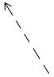

D

B

C

1. The diagram above represents a feedback cycle. In general terms, B and C refer to the
   1. modulator and effector.
   2. receptor and response.
   3. receptor and effector.
   4. modulator and response.
2. An appropriate modulator in this cycle would be
   1. Medulla oblongata
   2. Hypothalamus
   3. Pituitary gland
   4. Thyroid gland
3. The difference between white and grey matter within the brain is:
4. The white matter is on the outside away from the nerve tracts, whilst the grey matter is on the inside.
5. The grey matter contains the unmyelinated nerve fibres and the white matter contains the cell bodies.
6. The white matter contains the dendrites of neurons, the grey matter contains the nerve fibres.
7. The grey matter contains the cell bodies of neurons and the white matter contains the myelinated nerve fibres.
8. The structure just above the point where the spinal cord enters the skull and is responsible

for regulating autonomic responses would be the

* 1. hypothalamus.
  2. cerebrum.
  3. cerebellum.
  4. medulla oblongata.

1. The part of the human brain that regulates hunger, thirst and sleeping patterns is the
   1. hypothalamus.
   2. cerebrum.
   3. cerebellum.
   4. medulla oblongata.
2. The pituitary gland produces and secretes all of the following hormones except for
   1. growth hormone.
   2. thyroid stimulating hormone.
   3. prolactin.
   4. antidiuretic hormone.
3. Choose the two correct words, to complete the following sentence.

*The reabsorption of sodium ions and excretion of potassium ions is controlled by hormone __________ and secreted from the ___________.*

* 1. cortisol, adrenal cortex
  2. parathyroid hormone, parathyroids
  3. aldosterone, adrenal cortex
  4. cortisol, adrenal medulla

1. An individual contracted malarial parasite after a mosquito took a blood meal from them. Which of the following methods would describe how this disease was transmitted?
   1. By contact
   2. By a vector
   3. By body fluids
   4. By ingestion
2. Which of the following is not an example of a non-specific defence?
   1. Sebum which contains substances that kill bacteria.
   2. The beating motion of cilia within the respiratory system.
   3. Cerumen produced by the gastric pits, killing most bacteria that are swallowed.
   4. Urine is slightly acidic and provides a flushing action.
3. Which of the following is true about passive immunity?
   1. The patient’s immune system is stimulated to produce antibodies
   2. The patient receives the antibodies for a specific pathogen, through an injection
   3. This type of immunity is prolonged due to the development of memory cells
   4. Only involves B lymphocytes, while the T lymphocytes are not stimulated.
4. The following event and subsequent response that best describes what happens during anti-body mediated immunity, would be the
   1. T lymphocyte presents the antigen to the B lymphocyte; the B lymphocyte produces clones and memory cells.
   2. B lymphocyte is activated by an antibody; the B lymphocyte produces clones and memory cells.
   3. B lymphocyte is activated by an antigen; the B cells can become either a plasma, suppressor or memory cell.
   4. B lymphocyte is presented with an antigen; the B lymphocyte may become a clone that secretes specific antibodies.
5. Herd immunity is most easily achieved by providing
   1. natural passive immunity.
   2. artificial active immunity.
   3. artificial passive immunity.
   4. natural active immunity.
6. Which of the following is a property of a spinal reflex?
   1. They occur under the conscious control of the cerebrum.
   2. They are learnt through repetition.
   3. They involve a small number of neurons.
   4. They are regulated by positive feedback.
7. Actinomycetes are bacteria that produce a substance that can penetrate a cell membrane

and disrupt protein synthesis, stopping the unicellular organism from reproducing. This

type of substance is referred to as an/a

* 1. antiviral drug
  2. narrow-entry antibiotic
  3. bactericidal antibiotic
  4. bacteriostatic antibiotic

1. Aerobic respiration is a chemical reaction that produces a number of waste products which are detected by different sensory receptor to maintain homeostasis. Those receptors that would be most sensitive to these wastes would be
   1. osmoreceptors, chemoreceptors and alpha cells.
   2. carotid and aortic bodies, osmoreceptors and central chemoreceptors.
   3. thermoreceptors, osmoreceptors and beta cells.
   4. peripheral and central chemoreceptors.

The next two questions refer to the diagram below

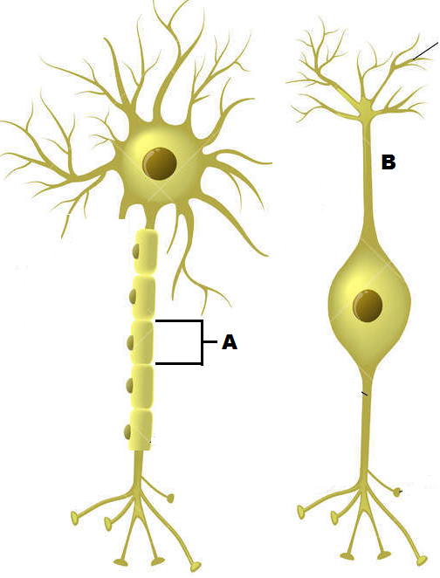

1. The cell labelled A has the following function.
   1. Forms the myelin sheath
   2. Provides a conducting surface.
   3. Secretes neurotransmitters.
   4. Speeds up hormonal impulses.
2. The cell labelled B is a:
   1. Sensory multipolar neuron
   2. Motor bipolar neuron
   3. Unipolar interneuron
   4. Sensory bipolar neuron
3. The role of histamine is to:
4. prevent clotting.
5. make the walls of the blood capillaries more permeable.
6. decrease the blood flow to the infected area.
7. attract thrombocytes to the infected area.
8. Increasing the carbon dioxide concentration in the blood will
   1. increase the pH of the blood
   2. incur hyperventilation
   3. stimulate a nervous impulse through the vagus nerve
   4. trigger a response from the chemoreceptors before a decrease in oxygen concentration.
9. Glucagon will maintain blood glucose at homeostatic levels by
   1. decreasing the production of glycogen
   2. increasing the formation of glycogen
   3. increasing the catabolism of glycogen
   4. increasing the anabolism of glycogen

The following information relates to questions 23, 24 and 25.

A patient has complained of the following symptoms to their doctor:

* Feeling a lack of energy
* Unexplained weight loss
* Frequently craving foods with sugar

In response, the doctor had the patient’s blood glucose levels tested over

five consecutive days. The patient’s results, measured in millimoles per litre, can be seen in the

table below.

|  |  |  |  |  |  |
| --- | --- | --- | --- | --- | --- |
| Day | 1 | 2 | 3 | 4 | 5 |
| Glucose concentration (mmol/L) | 4.0 | 4.3 | 4.9 | 4.7 | 5.1 |

A normal range is between 4 and 6 mmol/L

1. The mean glucose concentration in the patient’s bloodstream over the five days was
   1. 4.6
   2. 4.9
   3. 4.8
   4. 4.5
2. The percentage change in the patient’s blood glucose level from the first day to the fifth

day was

* 1. 27.5% decrease
  2. 21.5% increase
  3. 27.5% increase
  4. 21.5% increase

1. Which of the following patient’s glands and their respective hormones may be underactive?
   1. Beta cells of the pancreas; glucagon
   2. Adrenal cortex; cortisol
   3. Alpha cell of the pancreas; insulin
   4. Thyroid gland; ACTH
2. Complete the following sentence by choosing the correct sequence of words.

*Once a hormone has produced the required effect, it needs to be broken down. This mostly occurs in the _______ and the ________. This process is known as ___________*

* 1. target cells; liver; enzyme amplification
  2. kidney; liver; negative feedback
  3. target cells; kidney; hormone clearance
  4. kidney; liver; hormone clearance

1. Which one of the four substances would not be found in a traditional vaccine?
   1. Attentuated micro-organisms
   2. Virulent micro-organisms
   3. Dead micro-organisms
   4. Inactivated bacterial toxins

1. Choose the best description of a virus
   1. A protein coat surrounding either DNA or RNA
   2. A protein coat with both RNA and DNA
   3. A non-living entity that causes disease
   4. An organism that invades and multiplies within bacteria
2. Choose the best description of a bacteriophage
   1. A virus that reproduces within bacteria
   2. A bacterium that is resilient to viral infections
   3. Bacteria that are injected with a virus to produce insulin
   4. Bacterium that have a specific rod shape and flagella
3. Choose the protective reflex that is correctly matched to its modulator and the nervous system that would stimulate it.
   1. Sneezing; medulla oblongata; somatic division
   2. Coughing; hypothalamus; autonomic division
   3. Vomiting; medulla oblongata; autonomic division
   4. Diarrhoea; medulla oblongata; autonomic division

**Section Two: Short answer 50% (100 Marks)**

This section has **eight (8)** questions. Answer **all** questions. Write your answers in the spaces provided.

Spare pages are included at the end of this booklet. They can be used for planning your responses and/or as additional space if required to continue an answer.

* + Planning: If you use the spare pages for planning, indicate this clearly at the top of the page.
  + Continuing an answer: If you need to use the space to continue an answer, indicate in the original answer space where the answer is continued, i.e. give the page number. Fill in the number of the question(s) that you are continuing to answer at the top of the page.

Suggested working time: 90 minutes.

**Question 31 (13 marks)**

The diagram below shows a section of skin with a number of parts that are involved in maintaining homeostasis.

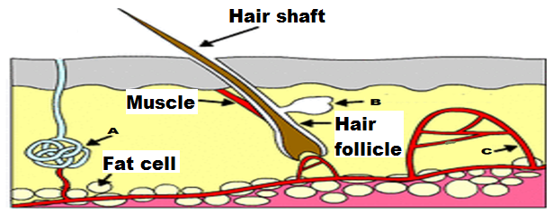

* + - 1. Identify the parts in the above diagram

A Sweat gland

B Sebaceous gland

C Capillary (3 marks)

* + - 1. There are two types of gland in the body. State the type of gland(s) that can be seen in the diagram above and explain why they are classified into their particular group.

Both glands = exocrine (1)

Exocrine = secrete into ducts that lead to the surface (1)

(2 marks)

* + - 1. Parts A and C are both involved in a homeostatic mechanism. In the space below, draw a stimulus-response-feedback model to show what role parts A and C have in maintaining homeostasis. (6 marks)

Receptor – Thermoreceptors

(in skin/hypothalamus) (1)

Stimulus – rising body temperature (1)

Feedback – body temperature falls (1)

Modulator - Hypothalamus (1)

Effectors – NO MARK AWARDED as effectors already identified in Question 31 a).

Responses

Vasodilation of capillaries (1)

OR

Secretion of sweat onto skin (1)

d) Explain how the secretions of Part B assist homeostasis.

* An oily secretion called sebum is released onto the skin (1).
* It contains substances that kill some pathogenic bacteria (1)

(2 marks)

**Question 32 (16 marks)**

Scientists wanted to test the hypothesis that neurotransmitters released from a specific group of nerve cells (called the NTS) found within the medulla oblongata, increases long term memory retention in humans. The NTS are ascending tracts that link to the amygdala, which is a part of the brain responsible for emotional memories.

To investigate this theory, scientists exposed two rats to inhibitory avoidance training. To do this experiment, each rat was tested separately. They were placed into a box, facing a closed sliding door. The box was well lit with white light. Once the rat turned away from the door, the door was opened, allowing free access to a separate darker, secluded box. The moment the rat turned to face the open door, a timer was started and once the rat had completely entered the dark room, the door was closed and the time was stopped and recorded. Upon entering the dark room, a footshock (weak electrical current passed into the rat’s foot via the floor) was administered. Immediately after the footshock, the rat was removed from the dark box and given a dose of lignocaine into the NTS. Lignocaine is an anaesthetic that binds to sodium-gated channels and prevents them from opening.

Memory for the footshock training is assessed by retesting the rat from 24 to 96 hours later. In this test, the rat is placed in the well-lit box as before, the door is opened once the rat looks away and the time taken for the rat to enter the dark box where the footshock was received earlier is recorded. The time recorded is used as an indicator of the level of memory retention.

The results from the experiment can be seen below.

|  |  |  |
| --- | --- | --- |
| Time passed since rat given lignocaine  (hours) | Time passed before rat entered dark room (seconds) | |
| Rat not given lignocaine | Rat given lignocaine |
| 12 | 180 | 181 |
| 24 | 150 | 152 |
| 36 | 135 | 132 |
| 48 | 138 | 130 |
| 60 | 152 | 128 |
| 72 | 220 | 125 |
| 84 | 260 | 120 |
| 96 | 300 | 118 |

1. Identify the
   1. Independent variable: Administration of lignocaine (1)
   2. Dependent variable: Time passed before rat entered dark room (1)

(2 marks)

1. State why the scientist provided a rat with inhibitory avoidance training, but did not administer lignocaine.

* Control group (1)
* Allowed scientist to compare the response time to the rat that had their NTS blocked (1)

(2 marks)

1. Plot a graph of the information contained in the table. (5 marks)

* Title (1)
* Line graph (1)
* Appropriate/correct scale on both axis (1)
* Independent on the horizontal axis / dependent on the vertical and both correctly labelled (1)
* Legend / key provided to distinguish each line (1)

1. What conclusion can be drawn from the results?

* As more time passed since the injection of lignocaine, the retention of long term memory decreased. (1)
* As more time passed since the rat that was not given an injection of lignocaine, the retention of long term memory increased. (1)

(2 marks)

1. Name the process that would have been inactivated by the lignocaine in the NTS and explain why the post-synaptic knobs in the amygdala would have not been stimulated.

* Action potential (1)
* The sodium ions remain on the outside of the cell (1) (given the lignocaine stops the sodium-gated channels from opening) and
* the potassium ions remain on the inside of the cell, (1)
* leaving the cell polarised (1)
* The polarised cell cannot stimulate the cells of the amygdala / cannot cause an action potential to occur / cannot stimulate the neurons. (1)

(5 marks)

**Question 33 (19 marks)**

Refer to the diagram below and answer the questions that follow.

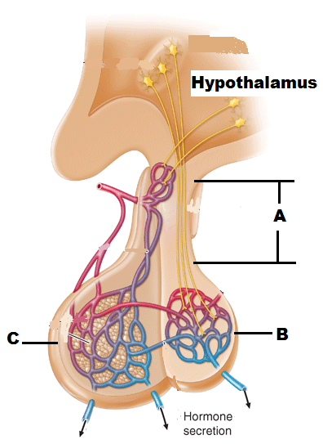

1. Identify the parts labelled in the diagram above.

A Infundibulum (1)

B Posterior lobe of pituitary gland (1)

C Anterior lobe of pituitary gland (1) (3 marks)

1. Describe the evidence you used to identify parts C and B

* Anterior lobe is connected to the hypothalamus by a complex network of blood vessels / capillaries (1)
* Posterior lobe is connected to the hypothalamus by nerve fibres (that come from nerve cell bodies) (1)

(2 marks)

1. Explain the different methods the hypothalamus uses to stimulate parts B and C, so they can release their respective chemicals.

* The anterior lobe is stimulated to release its hormones by inhibiting and releasing factors, (1)
* which reach the anterior lobe via the blood vessels (1)
* Hormones are produced in the nerve cell bodies in the hypothalamus (1) and then they pass along the nerve fibres to the posterior lobe (1) where they are released.

(4 marks)

1. Using the space below, draw a sequence diagram that shows how the organs shown in the diagram above regulate the water concentration in the bloodstream.

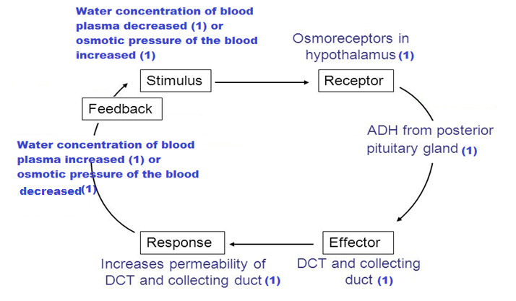

(6 marks)

1. The diagram below indicates two endocrine tissues labelled A and B. In the boxes provided for EACH tissue (A – B):
   1. Name ONE hormone secreted by that tissue (2 marks)
   2. State ONE principal action of that named hormone on the target tissue (2 marks)

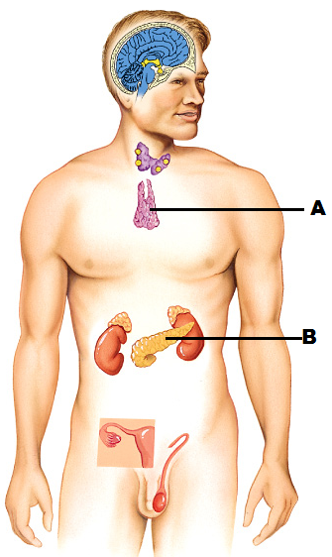

Tissue B

1. Insulin OR Glucagon (1 mark)
2. Insulin - Stimulates uptake of glucose OR

Glucagon – Stimulates breakdown of glycogen and fat

(1 mark)

Tissue A

1. Thymosins (1 mark)
2. Stimulates development and maturation of T lymphocytes

(1 mark)

**Question 34 (16 marks)**

Nicole is highly allergic to shellfish and if she accidentally consumes any product with shellfish in it, she can go into anaphylactic shock. Symptoms of anaphylaxis include a red and hot rash, throat or tongue swelling, difficulty breathing, vomiting and low blood pressure. In the event she does go into anaphylactic shock, she carries an EpiPen®, which can provide her with a dose of epinephrine (adrenaline) and alleviate the symptoms.

1. Name the protective reflex that occurs as a result of the anaphylactic shock and describe how it occurs.

* Vomiting (1)
* Contraction of the muscles of the abdomen and diaphragm that expels the stomach contents (1)
* Zero marks for stating that stomach contracts. (2 marks)

1. Name the internal non-specific defence that would cause the rash and the swelling of the tongue, throat and respiratory system. Explain the process that would occur, that would lead to the rash and swelling in those areas.

* Inflammatory response (1)
* Allergen stimulates mast cells to release histamine and heparin (1)
* Histamines increase blood flow to affected areas (1)
* Heparin prevents clotting in the affected area, (1)
* Other chemicals released by the mast cells attract phagocytes to the area, which all contribute to (1)
* swelling, heat and redness in the affected area / tongue/ skin (1).

(6 marks)

1. State how the adrenaline would make breathing easier and increase the blood pressure.

* Adrenaline dilates bronchioles to allow more air into the lungs (1)
* Adrenaline causes vasoconstriction of blood vessels in the skin / vasodilation of the blood vessels to the heart / lungs (1)

(2 marks)

1. Adrenaline is classified as an amine hormone. Explain how this hormone acts on a cell and causes the cell to produce a particular protein.

* Attaches to receptor proteins in the cell membrane of the target cell (1)
* This causes a secondary messenger to diffuse through the cell (1) and
* Activate production of a specific protein (1)

(3 marks)

1. An adult EpiPen® typically injects 0.3mg of adrenaline. If the device was to inject anymore, it would not have any further effect. Explain why.

* Adrenaline is dependent upon the receptor proteins in the cell membrane (1)
* There are a limited number of receptor proteins in the cell membrane(1)
* If every receptor is bound to an adrenaline molecule / if receptor saturation has been achieved, the cell’s rate of adrenaline uptake cannot increase any further (1)

(3 marks)

**Question 35 (8 marks)**

Look at the diagram below and answer the questions that follow.

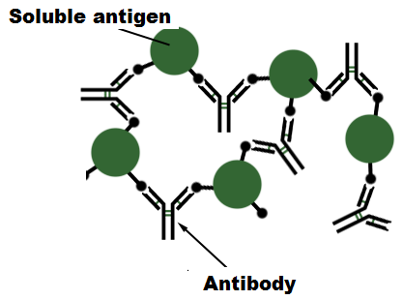

1. State what method is being used by the antibodies to provide resistance to infection.

* The antibodies are reacting with the soluble antigens to make them insoluble (1)
* therefore more easily consumed by phagocytes (1)

(2 marks)

1. Describe three other methods antibodies can use to inactivate an antigen.

Any three (3) of the following for a max of three (3) marks

* Combine with foreign enzymes or bacterial toxins to inactivate them
* Bind to the surface of viruses and prevent them from entering cells
* Coat bacteria to make them easier to be consumed by phagocytes
* Agglutination, making phagocytosis easier.

(3 marks)

1. In order to ensure vaccines are safe to use on the general population, they are extensively trialled. Name and briefly describe a potential problem that could occur when providing a vaccine.

* Any of the following to a maximum of 2 marks.
* Allergic reaction (1) Occurs due to the medium the vaccine was cultured in (1)
* Cross-species disease introduction (1) It is impossible to completely isolate one virus from others within an animal tissue that is being used as a culture medium (1)

(2 marks)

1. When a new vaccine is first introduced, follow up studies are required to determine how long the vaccine will provide protection for. State the name given to this type of investigation.

* Longitudinal study (1 mark)

**Question 36 (15 marks)**

A freestyle diver is someone who swims under water without any breathing apparatus, to the deepest possible depth, before returning to the surface. In an effort to stay under water for as long as possible, they will hyperventilate. The danger of this sport, is the diver could lose consciousness and drown. This consequence is referred to as “blacking out”.

The two graphs below show the relationship between the levels of oxygen and carbon dioxide within a freestyle diver’s bloodstream. One of the graphs shows what happens to the gas levels without hyperventilating. The other shows what happens to the gas levels when the diver hyperventilates before diving. Study these two graphs and answer the questions that follow.

Graph 1

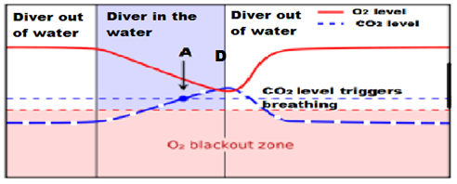

Graph 2

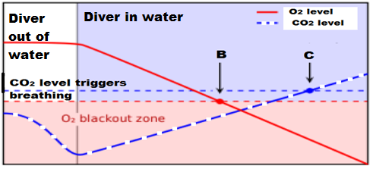

1. State which of the two graphs shows what happens to the gas levels when the diver has hyperventilated. Explain your answer.

* Graph 2 (1)
* The carbon dioxide level has been lowered before the swimmer has entered the water (1)

(2 marks)

1. Looking at the points indicated by the letters A, B and C on the graphs above, state how the diver’s body is responding and what the diver is doing

* Point A: The carbon dioxide level has built up to a point that they are being forced to take a breath, but the diver has not (1)
* Point B: The oxygen level has decreased to the point where the diver could lose consciousness, the diver is still holding their breath (1)
* Point C: The carbon dioxide level has built up to a point that they are being forced to take a breath, but they are still under water. (1)

(3 marks)

1. One of the graphs above shows where the diver has reached the surface and taken a breath. Circle and clearly label this area on the relevant graph above, using the letter D.

* See Graph 1 above.

(1 mark)

1. Hyperventilating can be brought on through physical stress. To help someone recover from hyperventilation, they can breathe into and out of a paper bag a number of times. Explain why this technique prevents someone from losing consciousness and allows them to regain control over their breathing rate.

* Paper bag allows patient to breathe in CO2 again (1)
* CO2 levels rise, which lowers pH (1)
* Lower pH stimulates peripheral chemoreceptors/aortic and carotid bodies (1)
* Medulla oblongata/inspiratory centre triggered, (1)
* breathing rate increased / regulated (1)

(5 marks)

1. Hyperventilation can lead to respiratory alkalosis. This disorder causes a decrease in potassium and calcium levels within the bloodstream, which then leads to uncontrollable muscle cramping.

Complete the following table to summarise how the endocrine system would respond to the decrease in potassium and calcium.

1 mark for each correct column. (If only one correct per column = Zero marks)

|  |  |  |  |  |
| --- | --- | --- | --- | --- |
| Gland | Hormone name | Hormone level raised or decreased? | Target Cells | Main effects |
| Parathyroids | Parathyroid hormone | Raised | Bones / kidneys | Increases level of calcium in the blood |
| Adrenal cortex | Aldosterone | Decreased | Kidney | Decreases removal of potassium from the blood |

(4 marks)

**Question 37 (13 marks)**

1. Complete the diagram below of a reflex arc, by drawing in and clearly labelling the appropriate neuron(s) in the space below. The neuron leading to the effector has already been drawn for you.

(1 mark)

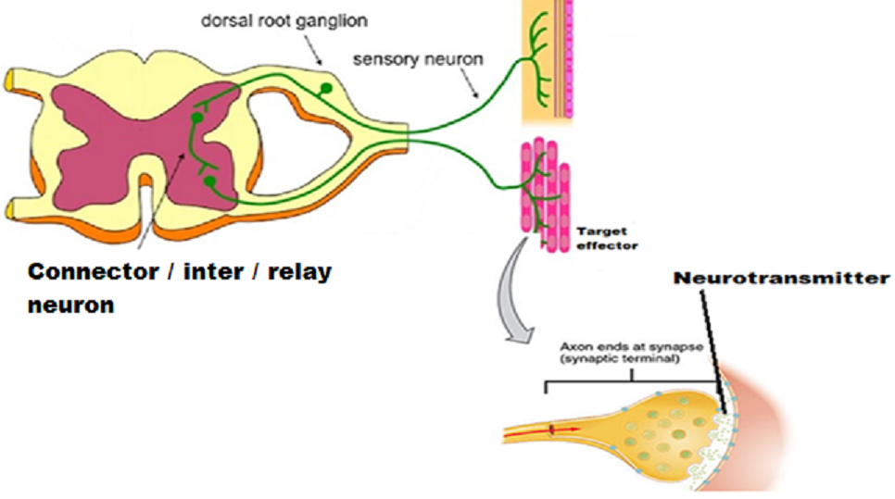

**Arrow used to indicate direction of impulse**

1. Draw an arrow(s) on the diagram to indicate the direction the impulse would travel through the reflex arc.

* See diagram above.

(1 mark)

1. Clearly label the dorsal root with ganglion and where the neurotransmitter would be located on the diagram above.

* See diagram above.
* 1 mark for each part clearly and correctly labelled.

(2 marks)

1. To make it easier to describe the various functions of the peripheral nervous system, it has been classified into divisions and subdivisions.

Complete the following table to classify and describe the neural pathway shown in the diagram above.

1 mark for each correct column. (If only one correct per column = Zero marks)

|  |  |  |  |  |
| --- | --- | --- | --- | --- |
| Division(s) | Reason for choosing division(s) | Subdivision(s) | Reason for choosing subdivision(s) | Name of neurotransmitter(s) released |
| Afferent and  Efferent. | Afferent -Carrying information into central nervous system (CNS)  Efferent - and away from the CNS. | Somatic | Carrying messages to skeletal muscle  Or  Only one motor neuron carrying impulse from the CNS | Acetylcholine |

(5 marks)

1. In order for a reflex arc to be effective, it needs to be very fast. Describe the properties of a reflex arc that allow the impulse to travel quickly.

* A stimulus is required, the reflex is not spontaneous (1)
* A reflex is involuntary, it occurs without conscious thought (1)
* A reflex is rapid, only a small number of neurons are involved (1)
* A reflex is stereotyped, it occurs the same way every time. (1)

(4 marks)

**Section Three: Extended answer 20% (40 Marks)**

______________________________________________________________________________

**Question 38 (20 marks)**

1. There are a number of endocrine homeostatic mechanisms that regulate the blood glucose concentration and maintain it at a normal level.

Describe any **three** of these processes, identifying the hormone, the effector involved and the location where the response occurs.

(12 marks)

|  |  |
| --- | --- |
| For each process there are a total of FOUR marks.  One mark for hormone name  One mark for effector  Two marks for process/es | Marks |
| Hormone: Insulin | 1 **1A** |
| Effector: Beta cells | 1 **2A** |
| Processes   * Glycogenesis – conversion of glucose to glycogen in liver/muscles. * Lipogenesis – conversion of glucose to lipids in adipose tissue | 2 **3A**  **4A** |
| Or |  |
| Hormone: Glucagon | 1 **1B** |
| Effector: Alpha cells | 1 **2B** |
| Processes   * Glycogenolysis – conversion of glycogen to glucose in liver/muscles. * Gluconeogenesis – conversion of lipids and amino acids to glucose in the liver | 2 **3B**  **4B** |
| Or |  |
| Hormone: Cortisol | 1 **1C** |
| Effector: Adrenal cortex | 1 **2C** |
| Processes   * Glycogenolysis – conversion of glycogen to glucose in liver/muscles. * Gluconeogenesis – conversion of lipids and amino acids to glucose in the liver | 2 **3C**  **4C** |
| Or |  |
| Hormone: Adrenaline or noradrenaline | 1 **1D** |
| Effector: Adrenal medulla | 1 **2D** |
| Processes   * Glycogenolysis – conversion of glycogen to glucose in liver/muscles. * Glycogenolysis (Cori cycle) – lactic acid produced can be transported to liver and converted into glucose | 2 **3D**  **4D** |
| Or |  |
| Hormone: Thyroxine | 1 **1E** |
| Effector: Thyroid gland | 1 **2E** |
| Processes   * Increases absorption of glucose from the small intestine into the bloodstream * Increases rate of cellular respiration, leading to increased rate of glucose absorption into all cells of the body. | 2 **3E**  **4E** |

1. An individual’s basal metabolic rate can be affected by an over or under active thyroid gland.

Identify and contrast these two conditions and despite having so many differences, explain why they both cause fatigue.

(8 marks)

|  |  |
| --- | --- |
| **Each contrasted difference must be appropriately linked for 1 mark.** | |
| **MUST HAVE**  **Hyperthyroidism** – over active thyroid gland | **MUST HAVE**  **Hypothyroidism** – under active thyroid gland **(1)** |
| **Any one of the following pairs of differences, to a maximum of 3 marks.** | |
| Caused by immune response reaction | Lack of iodine available to thyroid gland **(2)** |
| Rapid heart beat | Slow heart beat **(3)** |
| Unexplained weight loss | Unexplained weight gain **(4)** |
| Increased appetite | Decreased appetite |
| Increased core body temperature / reduced tolerance to hot climate | Decreased core body temperature / reduced tolerance to cold climate |
| Reasons for both causing fatigue. Maximum of 2 marks per condition. | |
| Over active thyroid gland 🡪 more thyroxine released 🡪 greater basal metabolic rate than necessary **(5)** which then leads to  🡪 greater consumption of food/glucose 🡪 low blood glucose concentration 🡪 fatigue **(6)** | Under active thyroid gland 🡪 less thyroxine released 🡪 slow basal metabolic rate **(7)** which then leads to  🡪 reduced cellular respiration 🡪 less energy / ATP produced 🡪 fatigue **(8)** |

**Question 39 (20 Marks)**

Multiple sclerosis (MS) is an autoimmune disease, where T lymphocytes attack and destroy oligodendrocytes within the central nervous system. These cells serve the same function as the Schwann cell of the peripheral nervous system. Specific symptoms of this disease can include a decreased ability to detect stimuli, weakened muscles and loss of fine muscle coordination.

1. Compare and contrast the transmission of a nerve impulse along an unmyelinated and myelinated fibre and explain why myelinated fibres are faster.

(8 marks)

|  |  |
| --- | --- |
| **Unmyelinated** | **Myelinated** |
| Depolarisation of one area of the cell membrane causes an action potential to flow onto the membrane immediately adjacent to the stimulus. **(1)** | Depolarisation of one area of the cell membrane causes an action potential to jump from one node of Ranvier to another. **(2)** |
| The nerve impulse/exchange of ions (NOT action potential) moves along the entire length of the neuron/axon. **(3)** | The nerve impulse/exchange of ions (NOT action potential) only occurs at the nodes of Ranvier or cannot occur where the axon is myelinated. **(4)** |
| Lower concentration gradient of ions either side of the membrane. **(5)** | Higher concentration gradient of ions either side of the membrane at the nodes of Ranvier. **(6)** |
| The nerve impulse / message (NOT action potential) travels along the whole length of the fibre, reducing its speed. **(7)** | As the action potential jumps from one node of Ranvier to the next on the myelinated fibre, the impulse can travel faster. **(8)** |

1. Explain how a healthy individual has the ability to distinguish stimuli of a different intensity, yet someone with MS gradually loses the ability.

(6 marks)

* The strength of a stimulus is determined by the number of nerve fibres that are stimulated **(1)** where
* A strong stimulus will cause the depolarisation / overcome the threshold value of more nerve fibres than a weak stimulus (2) and
* more nerve impulses will be generated within a given amount of time compared to a weak stimulus (3)
* Someone with MS loses the ability to distinguish between different stimuli as some of their sensory neurons have lost their myelin sheath. (4)
* Once a stimulus has been initiated, the speed/frequency of the impulse will be decreased (5) and hence

1 of the following for a maximum of 1 mark

* the number of impulses reaching the brain/modulator (6) OR
* decreasing the persons response time / sensitivity (6)

1. Parturition (child-birth) involves the actions of the nervous and endocrine system. Describe four differences between the actions of these two systems during parturition and explain why it is possible for a woman with MS to still give birth, even though her muscles are weakened by the damaged motor neurons.

(6 marks)

Any four of the following five differences = 4 marks.

Each difference MUST be correctly matched for one mark.

|  |  |  |
| --- | --- | --- |
| Characteristic | Nervous system | Endocrine system |
| Nature of message | Electrical impulse and neurotransmitter | Hormone / oxytocin **(1)** |
| Transport of message | Along the membrane of neurons | Bloodstream **(2)** |
| Cells affected | Impulses from the cervix to the brain/hypothalamus | Uterus **(3)** |
| Time taken to respond | In a healthy person - rapid | Slower – seconds/hours **(4)** |
| Duration of response | Stops as soon as the foetus is born and is no longer pressing against the cervix | Uterus continues to contract after the foetus is born (to expel placenta and can contract during initial breast feeding). |

* A women can still give birth because, although she may have lost sensitivity, the impulses would still reach the brain/hypothalamus to stimulate the release of oxytocin **(5)** and
* Her uterus would still contract, as it is being stimulated by the oxytocin that is delivered by the bloodstream and not by motor neurons **(6)**

**Question 40 (20 marks)**

Tuberculosis is a disease caused by a bacterial infection. Border security officers on the US side at the Mexico and US border are often required to refer visitors to a screening unit that detect for tuberculosis infections. One of the initial tests is measuring the core body temperature and detecting for swollen lumps around the neck.

1. State which two non-specific responses the medical staff are detecting for and describe how each of these processes work to reduce the infection.

(10 marks)

* Fever **(1)**
* Upon infection, the inflammatory response brings white blood cells to the area **(2)**
* White blood cells release pyrogens which stimulate the hypothalamus **(3)** to
* raise the body’s core temperature **(4)**
* A high body temperature can inhibit the growth of (some) bacteria (and viruses) **(5)**
* Swollen lymph nodes **(6)**
* Lymph fluid containing the bacteria enter the lymph nodes and **(7)**
* pass through a meshwork of fibres / lymphoid tissue **(8)** which
* trap/capture the bacteria **(9),** then
* the macrophages in the lymph nodes ingest the bacteria by phagocytosis **(10)**

Tuberculosis bacteria invade and replicate inside the cells of their host. Subsequently, the body responds by disrupting the intracellular phase of the bacterial infection.

1. State the name of the specific immune response that would be used for this type of bacteria and explain the events that would occur to eradicate the disease in the short term and prevent its return in the future.

(10 marks)

* Cell-mediated immunity or cellular immunity **(1)**
* B-cells or macrophages present the antigen/bacterium to the T-cell **(2)**
* T-cells are sensitised, enlarge and divide to become clones **(3)** which,
* differentiate into three kinds of cell **(4)**
* Killer T cells attach to the bacterium and secrete a substance that destroys the bacterium **(5)**
* Helper T cells secrete a number of substances that:
  + cause lymphocytes at the infection to become sensitised (intensifying the response) **(6)**
  + attract macrophages to the infection site, which ingest the bacterium **(7)**
  + intensify the phagocytic activity of macrophages **(8)**
* Clone cells that remain in the lymph nodes become memory cells **(9)**, which can initiate a faster response to any subsequent infections **(10)**

References

Question 18-19

Image retrieved 26 September 2017 from

[https://www.dreamstime.com/stock-illustration-types-neurons-basic-neuron-unipolar-pseudo-unipolar-neuron-bipolar-multipolar-neuron-cell-body-different-image52092345#](https://www.dreamstime.com/stock-illustration-types-neurons-basic-neuron-unipolar-pseudo-unipolar-neuron-bipolar-multipolar-neuron-cell-body-different-image52092345)

Under the Dreamstime license

Question 31

Image retrieved 27 September 2017 from

<http://gcsebiologycore.blogspot.com.au/2014/09/homeostasis.html>

Under the Common Creative license

Question 33

Image retrieved 27 September 2017 from

<http://accessmedicine.mhmedical.com/content.aspx?bookid=331&sectionid=40727144>

Under the Free Images license

Question 33 (d)

Image retrieved 3 October 2017 from

<http://slideplayer.com/slide/6940400/>

Under the Free Images license

Question 33 (e)

Image retrieved 26 October 2017 from

[www.thinglink.com/scene/497504539574796289](http://www.thinglink.com/scene/497504539574796289)

Under the Common Creative license

Question 36

Image retrieved 27 September 2017 from

<http://tecidc.com/go-pro/dive-theory-english/idc-physiology/>

Under the Free Images license

Question 37

Image retrieved 3 October 2017 from

<https://www.thinglink.com/scene/647049245123149824>